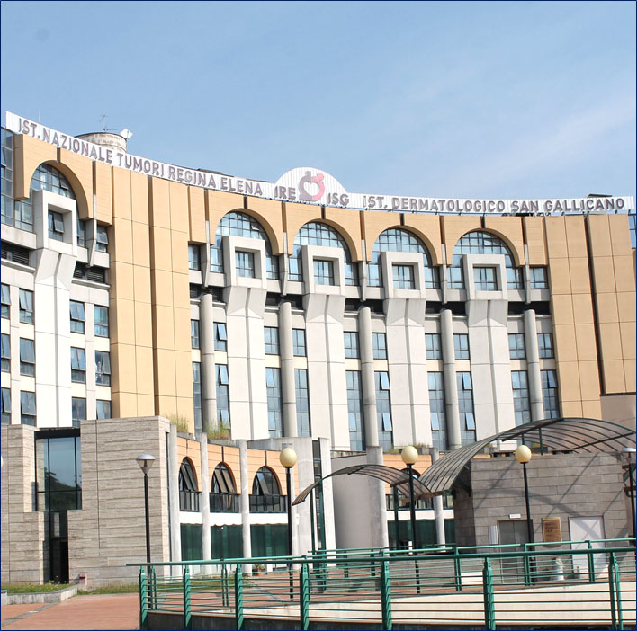

ESR-6. Liquid biopsy: circulating/blood
microRNAs as novel non-invasive
diagnostic biomarkers in brain cancer

AiPBAND, Marie Sklodowska-Curie Action H2020-MSCA-ITN-2017,
Grant Agreement 64281

We are looking for a highly qualified and ambitious candidate for the position of an early stage researcher (ESRs) within the framework of the European Innovative Training Network AiPBAND (An Integrated Platform for Developing Brain Cancer Diagnostic Techniques; https://sites.google.com/view/aipband-itn), in order to participate in specific ESR-6 projects with the primary objective to discover new molecular blood biomarkers (microRNA) for brain tumors and use them for diagnostic purposes..

The selected candidate will be involved in a 3-year well-funded research project, under the Marie Sklodowska-Curie Action H2020-MSCA-ITN-2017, as well as have the opportunity to be enrolled in a PhD program at the University of Catania.

The main activities of the ESR-6 specific project will be performed at the hosting Institution, the IRCCS Regina Elena National Cancer Institute (IRE), Dept. of Research, Advanced Diagnostics andTechnological Innovation. Oncogenomic and Epigenetic Unit- Translational Research Area, Rome- Italy. As a part of the project training and PhD program, the candidate will have periods of study also in 2 or 3 other collaborating institutions and will participate in a series of workshops and training sessions, where he/she will work together with other AiPBAND researchers and their supervisors (see mobility and secondment for the ESR6).

The IRE is a well-known Cancer Research Institute that focuses on tumor biology, epigenetic and translational medicine and that has been accredited by the Organization of European Cancer Institutes (OECI). It provides a dynamic and highly interactive research environment that is strongly connected with the clinics and translational medicine. The candidate will also benefit from the new laboratory facilities and equipment that our institute has recently set up where he/she may find a young stimulating work environment composed of post-doctoral researchers, undergraduate students and senior researchers with great expertise and willingness to support young researchers directly. This environment will ensure that he/she will be exposed to state-of-the-art technologies and methodologies necessary to reach his/her goals.

GENERAL REQUIREMENT FOR THE CANDIDATE:
• Qualifications. The candidate must have a Bachelor degree with honors in a relevant field. A Masters degree cum laude would be preferred. The candidate must not have been awarded any doctoral degrees
• Mobility Rule. At the time of recruitment, the candidate must not have resided or carried out his/her main work activities (work, studies, etc.) in Italy in the last three years for more than 12 months.
• Early Stage Researcher Rule. The candidate must have less than four-years of research experience at the selection time. This requirement must be respected at the time of recruitment at IRE (the first day of employment of the researcher for purposes of the action, see starting date).
SPECIFIC REQUIRED PROFILE FOR ESR-6
Organization/Company: IRCCS Regina Elena National Cancer Institute
Location: Via Elio Chianesi, 53; 00144 Rome/Italy
Degree: Master’s degree in Biological/Biomedical Science or equivalent
Type Of Contract: Fellowship
Job Status: Full-time
Salary: Maximum gross salary € 39.800 per year, excluding allowances
Start activity Date: September 1st 2018
Employment Duration: 36 months

JOB DESCRIPTION
The primary objective of the ESR 6 is to identify molecular blood biomarkers (microRNAs) for brain tumors and use them for diagnostic purposes. The secondary aim is to use these as non-invasive biomarkers for glioma classification and staging. Blood and serum samples will be obtained from brain tumor patients recruited at the IRE and global miRNA expression profiling will be performed by small RNASeq. Blood biomarkers discovered at IRE, will be cross-validated by in silico study (ESR1; PU) and two brain FFPE studies (ESR8; UCL & ESR9;SU).

Competences
• Background in cell/molecular biology particularly focusing on microRNA’s role in tumors; knowledge of neuroscience and brain tumor biology are also appreciated.
• Basic knowledge in biochemistry, molecular biology and cell biology techniques and on innovative techniques in molecular biology (e.g. microarray, NGS, digital PCR, Crispr/Cas9) focusing on microRNA analysis.
• Basic knowledge of computational biostatistics & bioinformatics
• Excellent knowledge of written and spoken English.
The Candidate should be highly motivated in carrying out his/her research in a dynamic environment as part of this unique EU training program.
The Candidate should have solid communication skills, and be creative, eager to learn and able to work both independently and/or as part of a team
Mobility and secondment for the ESR6
The University of Catania, (Italy; 5 months, year 1 & 2) for PhD program and plasmonic techniques; Radbound University (Netherlands; 2 months, year 1) for NGS techniques used in DNA methylation biomarker discovery; Capital Medical University of China (1month, year 2) for international experience in a brain cancer clinic.
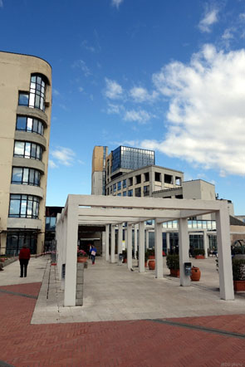
Application submissions
Your application should be submitted via the indicated e-mail address: sar@cert.ifo.it before 31st March 2018. Your application must include: a personal motivation letter, CV including name and contact details, and reference letters (optional)
Selection process
Candidates will be assessed on the basis of their CV, grades and motivation letter. Shortlisted candidates will be invited to hold a job interview.
Selection procedure will be made regardless of gender, nationality, religion, ethnicity and cultural background but aiming for a good balance among the group.

